USER MANUAL

PTM SERVER CAPACITY PLANNER

June 2022

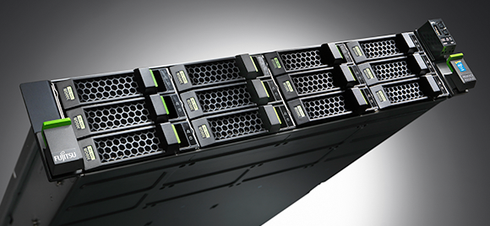

# DOCUMENT PURPOSE:

The purpose of this document is to provide a user manual of the Server Capacity Planner. This manual includes a description of the system’s functions and capabilities.

# INTENDED AUDIENCE:

1. Server Administrator

**USER INTERFACE:**

**FUNCTION:**

Search function:

1. Type the server name in the search box
2. Press <enter>

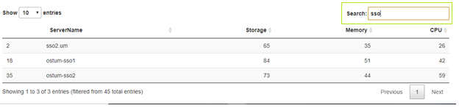

Download function:

1. Click 
2. From the save file screen, select the destination file you want to download

**OPERATION:**

Chose server capacity with ruler scale meter:

1. For storage score, slide the button to the right to select

2. For memory score, slide the button to the right to select

3. For CPU score, slide the button to the right to select

Respected data for chosen capacity:

Download the respected data:

1. Click 
2. From the save file screen, select the destination file you want to download

Downloaded data:

